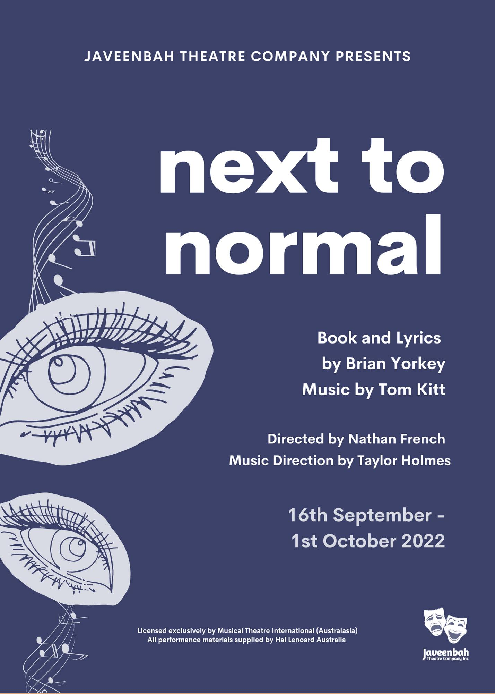

NEXT TO NORMAL AUDITIONS
SATURDAY 4th OF JUNE – Starting from 10am
Javeenbah Theatre – Sophie’s Space (Downstairs)
Cnr Stevens & Ferry Streets Nerang Qld 4211

Please Register for an Audition here:
Audition Registration Form: (Jot Form Link)

For further information or any queries please email us at N2NJbah@gmail.com
IMPORTANT AUDITION INFORMATION

Director: NATHAN FRENCH
Musical Director: TAYLOR HOLMES

SHOW DATES
September 16th, 17th, 18th, 23rd, 24th, 25th, 29th, 30th,
October 1st

REHEARSALS: Starting Sunday June 12th
Mondays: 7pm-10pm
Wednesdays: 7pm-10pm
Sundays: 10am-6pm

** Rehearsal times are approximations and may vary upon occasion. Full cast may not be required every rehearsal. A basic rehearsal outline will be available for viewing on audition day **

AUDITION DAY:
Prior to the audition date, you will be allocated a 10min audition timeslot, in which the panel will view the prepared pieces. This timeslot will be allocated after the completion of the registration form found earlier in this audition pack. Please make sure you arrive at an appropriate time before your audition as late arrivals or missed auditions may not be able to be accommodated.

WHAT TO PREPARE:
Vocals: Please prepare 2 contrasting musical theatre songs, 90 seconds in length that best show your vocal and acting ability. Please be advised that during your audition, the panel may not ask to hear both songs. You will need to provide backing tracks (AUX or USB – please NO CD’s) as no repetiteur will be available.
Acting: Please prepare a 1-min Contemporary Monologue of your choice that best shows your acting and character ability.

CALLBACKS:
Call-backs will be held on WEDNESDAY JUNE 8th in Sophie’s Space at Javeenbah Theatre starting from 7pm. You will be supplied material from the show to prepare if you are successful in gaining a call-back. Auditionees successful in receiving a role in the production will be contacted within a few days after call-backs.

EXPECTATIONS
Please note that if successful, you are committing to rehearsing up to 3 times a week until the show opens on the 16th of September and the 3 weeks of performances. Upon accepting a role in this production, you are agreeing to a commitment of all 9 performances. It is the responsibility of the cast member to ensure that this commitment is fulfilled. The creative team must be informed of any rehearsals that cannot be attended within a timely and appropriate manner. If any cast member has an abundance of missed rehearsals it may result in your removal from the production.
ABOUT THE SHOW
Next to Normal, explores how one suburban household copes with crisis and mental illness. Dad's an architect; Mom rushes to pack lunches and pour cereal; their daughter and son are bright, wise-cracking teens, appearing to be a typical American family. And yet their lives are anything but normal because the mother has been battling manic depression for 16 years. Next to Normal takes audiences into the minds and hearts of each character, presenting their family's story with love, sympathy and heart.

CHARACTER BREAKDOWN
The creative team are looking for a cast of 6 performers with strong vocal and acting ability to fill the following roles. The ages written below are the playing ages for each character; not necessarily indicative of the actors age.
Diana
A housewife suffering from bipolar depressive disorder. Attractive, appealing, and quick witted, yet suffering from manic depression and delusional episodes. Haunted by the past, Diana’s relationship with her husband and daughter grow more and more distant. She is determined to make her family perfect but is tortured by a death in the family.
Gender: Female
Age: Early 40’s
Vocal range: Mezzo/Belter: G3- F#5 (Strong mix to D5)

Gabe
Diana & Dan's son. Dashing, daring, rebellious, energetic, and carefree; he is the most affectionate towards Diana. He is a playful man and everything a mother could imagine. He is central to the dramatic conflict of the story.
Gender: Male
Age: 18 to 21
Vocal range top: Tenor: B2 - B4 (Falsetto to D5)

Dan
Diana's husband and Natalie and Gabe’s father. Protective, patient, and kind, yet worried and exhausted by family circumstances. He tries to keep his household together, often at the expense of his own personal interest and happiness.
Gender: Male
Age: Early 40’s
Vocal Range: Bari/Tenor: Ab2-A4 (Falsetto to Db5)
Natalie
Diana & Dan's troubled daughter. An accomplished pianist and hardworking student, her struggles are exacerbated by her mother's behaviour as she often feels invisible in the eyes of her parents. She is attracted to Henry and the attention he gives to her, yet she is also intimidated and has trouble accepting love from others.
Gender: Female
Age: 16 to 18
Vocal range top: Mezzo/Belter: G3-G5 (Strong Mix to E5)

Henry
Natalie's classmate. The all-around musician, philosopher, and a bit of a stoner. He has an intoxicating capacity for sympathy and romance. Henry is clearly interested in Natalie and expresses his feelings for her throughout the show. He becomes and important outlet for her feelings about her family and her mother’s illness.
Gender: Male
Age: 16 to 19
Vocal range top: Tenor G#2-A4 (Falsetto to C5)

Dr. Madden/Dr Fine
Dr. Fine is Diana’s psychopharmacologist. Practical and a bit cold. Dr Madden is Diana's handsome psychiatrist. Quite assured in his practice and considered somewhat of a rock star, he is a proficient doctor who is clearly concerned for Diana’s well-being. In Diana’s delusions he assumes the role of a rock star.
Gender: Male
Age: 30’s
Vocal range top: Tenor A2- A4

