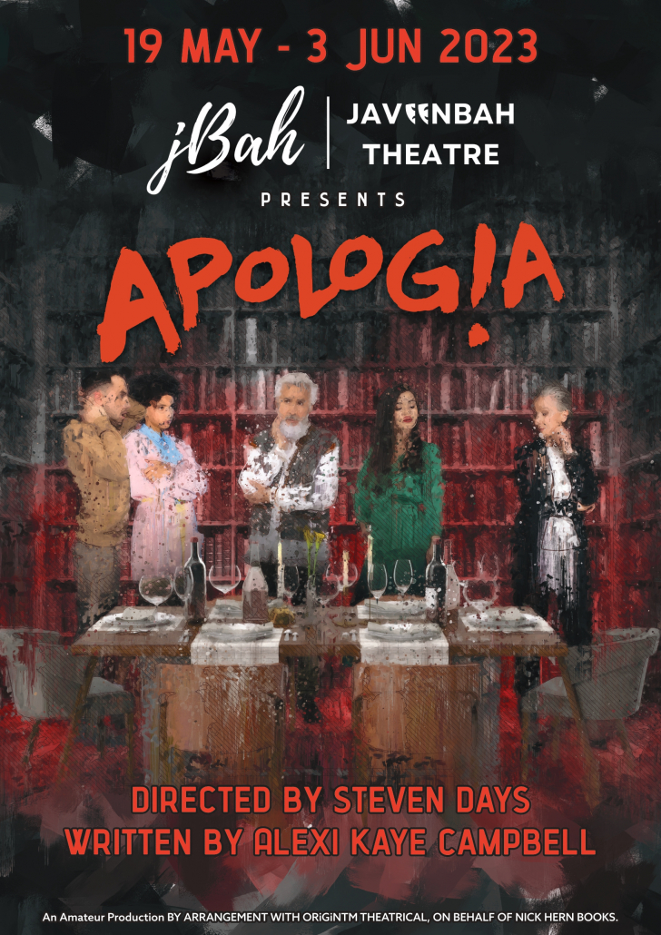

Auditions
In person auditions will be held 10am Sunday 26th February 2023 at Javeenbah Theatre.
As a play about belonging, family and the limitations of communication this small ensemble cast will need to blend as a family. Set in a single set of a cottage kitchen, actors will need to be open to playing their characters with realism and truth with the hope that audiences will see some of their own family members in the characters portrayed.
On the day of the audition, you will be required to present the side from those attached for the character for which you wish to be considered. If you would like to be considered for both younger female roles, please prepare both. You may present these at different times to allow you to focus on one at a time.
These will be open auditions starting with the prepared sides and followed by a workshop involving cold reading in groups.

Cast
2M, 3F

Characters
Kristen: (60 – 70) American (by birth, not choice), art historian and estranged mother. Kristen has a sense of superiority and righteousness because of her education as well as her past endeavours as a political protester.
Hugh: (60 – 70) Old, gay friend who was side by side with Kristen as she marched on the US embassy in London protesting the Vietnam war as the young American activist and then travelled the world as her dear friend and confidante.
Peter/Simon: (30 – 40) English and well-educated sons played by the same actor. One is a successful corporate banker, while the other goes from job to job while working on his novel (for seven years), struggling with depression and substance abuse.
Trudi: (20 – 40) American physiotherapist and Peter’s fiancée. A devout Christian who is always positive and tries to see the best in everyone.
Claire: (20 – 40) English TV Soap Opera star and Simon’s partner. Strong, confident and blames Kristen for much of Simon’s issues (though Kristen thinks Claire is the issue).

Rehearsals
Beginning Tuesday 28th February
Tuesday and Thursday from 7pm to 10pm
Sunday 2pm to 6pm

Season
May 19th to June 3rd
Friday and Saturday 7:30pm
Sunday 2pm

Sides

Kristin (p68)
You know nothing about what it means to live for something slightly larger than yourself so anything I say in my defence will sound like a foreign language to you. I don’t know how, I don’t know why this happened but somewhere along the line earning money – for the most part at the cost of other people’s suffering – seems to have become your only objective. And I honestly think that this new religious path you’ve decided to follow is just a way of assuaging what can only be a troubled conscience. Of course taking responsibility for your actions would release just as many endorphins as swaying in the pews does. The only difference is that they’d be a slightly better class of endorphins. You’d have earned them.
I could sit here for 24 hours and try and describe to you what it means to be political, what it means to fight for something other than your own material and domestic wellbeing and you wouldn’t understand. We could debate on what defines a good parent through the night and still we wouldn’t agree. But yes, I’m sure that in your version of what constitutes a good mother you are right that I failed you in every possible way.
But more than anything what appals and depresses me is that you have never once asked yourself – not really, not honestly – what it might have been like for me. Then, I mean. In Florence. When he took you away from me. In that way, you have persistently shown a quite catastrophic failure of imagination.
Your father would be proud of you.

Hugh (p42)
And this evening we are celebrating the birthday of the legend that is Kristin Miller. Pioneer of Arts and Letters, Champion of the Voiceless and Redemptive Saviour of the Western World.
Over the years we have watched you evolve from feisty American nymph to placard-wielding activist, from alarmingly coiffed Courtauld post-graduate to even more alarmingly coiffed hippy bride. In you pursuit of the common good you have offered yourself to as many causes as I’ve had social diseases. From the back streets of Palestine to the Parisian barricades you have made your presence felt most emphatically.
And most importantly, with your passionate, often lambasted contribution to the traditionally male-dominated bastion of art history you have always done things – and this is where I get serious and maybe even a little teary-eyed – with a whole load of heart. Tonight, Kristin Miller, we salute you.

Peter (p66)
Let’s talk about your book, Kristin. Let’s talk about your fucking book. Your memoir.
The way you write about art is thrilling. The supporting characters however seem a little sketchy.
I myself happen to be a little more thick-skinned shall we say but if I were Simon – if I were my brother Simon whose skin perhaps has never been quite as thick as mine – whose soul has never been quite as resilient – I might ask myself how in a book that calls itself a memoir, that purports to be your fucking life story, I don’t get a single fucking mention.
I am your son, I would say to myself, I would have liked to have played a slightly more pivotal part in what I’m sure it describes on the back flap as ‘the life and times of’. Would that be churlish of me?
That awful Italian you shacked up with for a couple of years got a whole fucking chapter.
And I have to now ask you the question I have been leading up to, the question I have been secretly asking myself for many, many years, the question that has been gnawing in my fucking chest since I was a small boy.
Why did this woman have children if she wasn’t prepared to do the job properly?
And I honestly don’t think that Claire being in a soap opera is the problem here.

Simon (p79)
Lately I’ve been doing some retracing.
Locating moments, finding locations, remembering, and then suddenly going, ‘Ah! So this is where it was. This is the place, that was the time when I first said to myself: “This is who I am, how it is, what I’m worth.”’
This is where I was shaped. This is where the music started.
This is the moment that set the soundtrack for the rest of my life. Finding those moments. That’s what I mean by retracing.
Because the thing is I’ve always felt this way.
Disjointed. And dislocated, Disillusioned, Dis-this, dis-that. Disturbed, distracted, discombobulated.
But you keep going. You shrug it off. You say to yourself, ‘This is the way it is for everyone.’ And then one day you realise that it isn’t. That your complete incapacity to feel any sort of self-worth is your own personal brand of misery. So you keep going until that day. And then suddenly you run out of fuel. You can’t lie to yourself anymore. You’ve always felt that way. And so it catches up with you, that’s all.

Claire (p94)
Did I ever tell you about my father?
I watched him slowly drown in a mountain of unpaid bills. When I was thirteen he was declared bankrupt. I used to come home every day after school and the bathroom door was always closed and the sound was always the same – the sound of my mother’s stiffed sobs. Then she’d come out with a smile on her face and cook dinner. One day, he left and never came back. My mother and I moved to a small rented flat and lived on benefits. The first day I moved my bed and there was a whole lot of blood on the wall. I spent all my time in that flat wondering what had happened before we arrived. I came up with quite a few upsetting scenarios. I had a vivid imagination.
Since then most of my life I’ve been running away from unpaid bills, stifled sobs and those dark-red stains.
That’s my individual story. But something tells me that somewhere along the line you’ve stopped listening to people’s individual stories. I wonder when that happened.
And then I decided it’s got nothing to do with me really. It’s not about me.
It’s about you.
And I expect it’s really a case of having to hold on to everything you are. Everything you were. The choices you made, the paths you followed. Because if you start to question them, if you start to doubt them… well then you’re fucked really, aren’t you?

Trudi (p14)
When Peter was in Liberia, I went with him. He was working all day and I was stuck in the hotel watching CNN.
I was kind of nervous going out on my own.
But there’s only so much TV you can watch. So Peter was out all day with people from the bank meeting with all these guys from the government. And I got bored. So I ventured out.
With this guy from the hotel who was like my bodyguard or something. Peter arranged it. It was crazy.
And we just walked around this marketplace and then this woman suddenly came up to me. She was very, very beautiful and quite young but when she opened her mouth I noticed she had no teeth. I mean not a single tooth. It was kind of freaky. Anyway, she grabbed me by the arm and asked me to stay there and she ran into her house and then came out with this mask and said the she would sell it to me. And I kind of fell in love with it.
The next day I took Peter over and showed it to him and persuaded him to buy it. For you. Because I knew you liked beautiful objects of art. And of course it’s the real thing, what I mean is it’s not like the ones they sell at the airport. It’s the real thing.
I really hope you like it.

